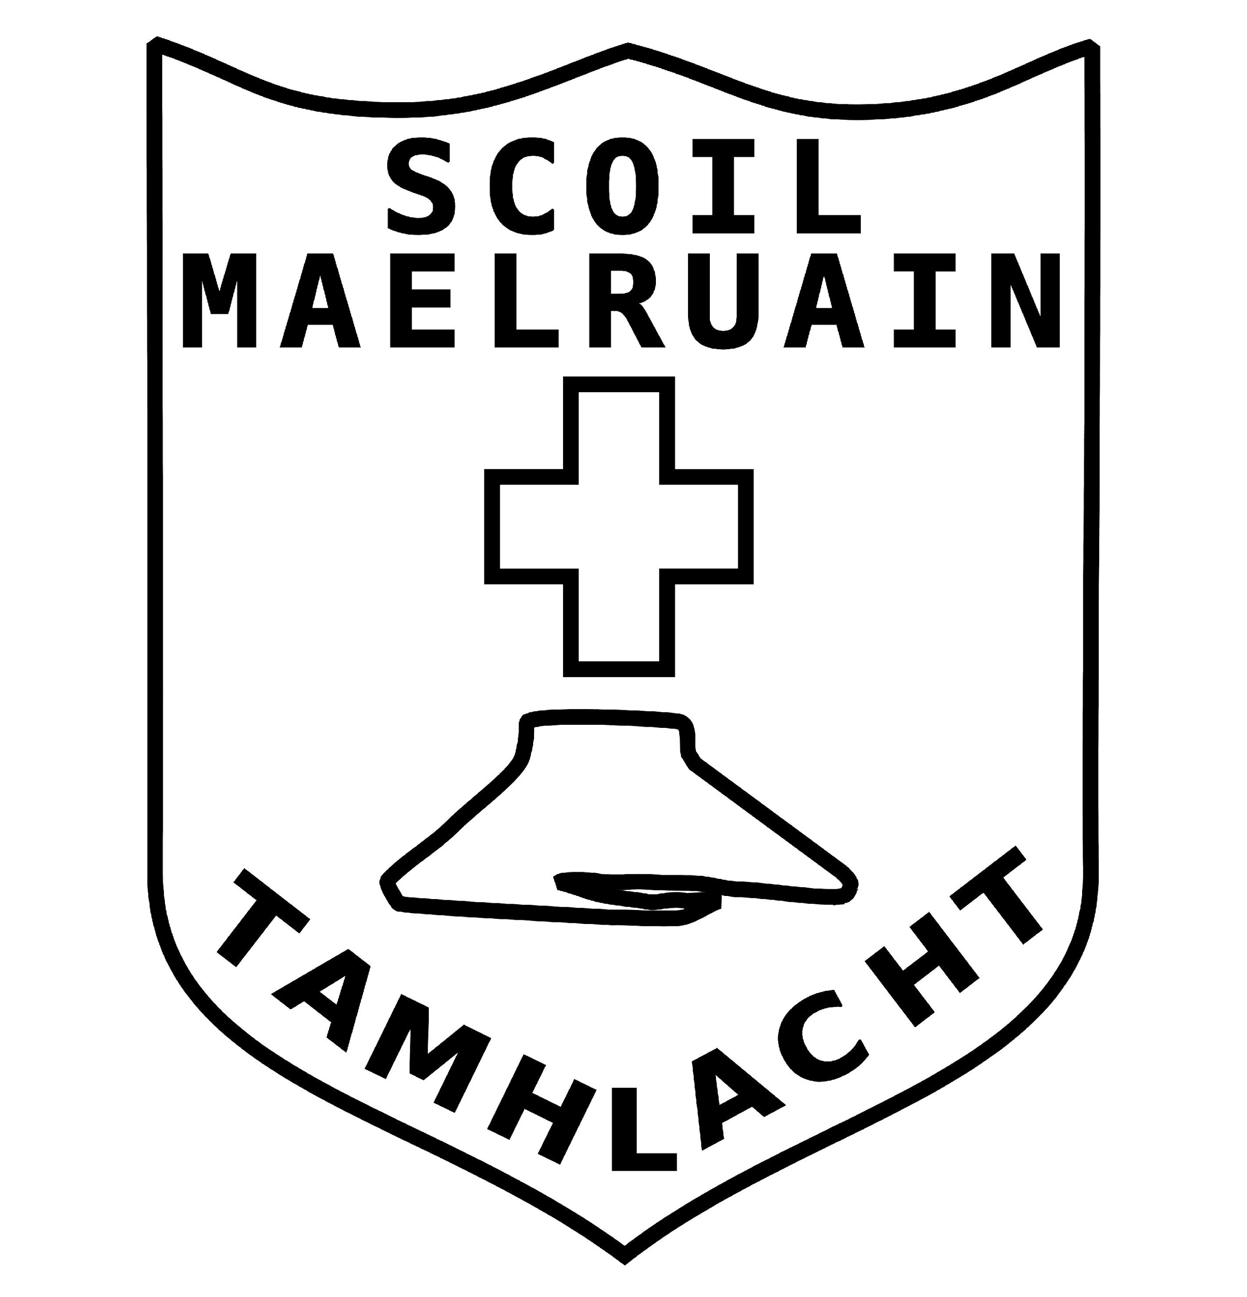 | Scoil Maelruain Junior  Old Bawn Ave.  Tallaght  Dublin 24.  01 4513967  www.scoilmaelruainjunior.org

Procedure for Registration for Enrolment to Junior Infants 2021

Section A
General introduction
This enrolment policy is being set out in accordance with the provisions of the education Act (1998), the Education Welfare Act (2000), the EPSEN Act (2004), the Rules for National Schools and all relevant legislation. This updated policy also reflects the Commencement Order signed by the Minister for Education and Skills on 3rd October 2018, bringing certain provisions of the Education (Admissions to Schools) Act 2018 into operation. The chairperson of the Board of Management, Mr. Max Cannon, and the principal teacher, Mairéad Ryan will be happy to clarify any further matters arising from the policy. This policy is subject to any directions which may be issued from time to time by the Minister for Education.

School Name: St Maelruan’s Junior National School

School Address: Old Bawn Avenue,
Tallaght
Dublin 24
Telephone No.: 01 4513967
Roll Number: 19462T

Denominational Character: Roman Catholic
Patron: Archbishop Diarmaid Martin
Total no of teachers in the school: 24 including Principal and 6 Special Education Teachers
Schedule of a Roman Catholic School
Scoil Naomh Maelruan Junior School, a Roman Catholic school (which is established in connection with the Minister for Education and Science) aims at promoting the full and harmonious development of all aspects of the person of the pupil: intellectual, physical, cultural, moral and spiritual, including a living relationship with God and with other people. The school models and promotes a philosophy of life inspired by belief in God and in the death and resurrection of Jesus Christ. The school provides religious education for the children in accordance with the doctrines, practices and tradition of the Roman Catholic Church and promotes the formation of the pupils in the Catholic Faith.

Members of the Board of Management
Mr. Max Cannon Chairperson
Mrs Joy Powell Patron’s Nominee
Mr Billy Coman Community Representative
Mr Paddy Heavey Community Representative
Mrs Gillian Doyle Parents’ Representative
Mr. Noel Tate Parents’ Representative
Mr. Darragh Macken Teachers’ Representative
Mrs Mairéad Ryan Principal

Range of Classes Taught: Junior Infants to Second Class

Normal School Opening Hours: 9.05 – 1.45 – Junior and Senior Infants
9.05 – 2.45 – First and Second Class

The school depends on the grants and teacher resources provided by the Department of Education and Science and it operates within the regulations laid down, from time to time, by the Department. School policy has regard to the resources and funding available.

The school follows the curricular programmes prescribed by the Department of Education and Science, which may be amended from time to time, in accordance with Sections 9 and 30 of the Education Act (1998).

Within the context and parameters of Department regulations and programmes, the rights of the patron as set out in the Education Act (1998), and the funding and resources available, the school supports the principles of:

- Inclusiveness, particularly with reference to the enrolment of children with a disability or other special educational need;
- Equality of access and participation in the school;
- Parental choice in relation to enrolment;
- Respect for diversity of values, beliefs, traditions, languages and ways of life in society

Our vision:
Each child is given the opportunity to reach his or her full potential; morally, socially, aesthetically, spiritually, emotionally, and physically, in a safe and caring learning environment. We strive to provide a holistic intercultural education for all children. We endeavour to lead children to become happy, respectful, independent and competent people capable of active participation in society. The holistic development of each child is achieved through the delivery of a broad curriculum and participation in various projects.

Section B Procedures for Application for Enrolment
Application Procedure

The Board of Management requests parents of children who will be four years of age by the first day of the new school year in Junior Infants to complete a written registration enrolment form available online. Dates and times for registration are confirmed at the start of the second term.

All registration forms for children registered for Junior Infants must be returned by post to the school by Monday 1st February 2021. Please do not come to the school in person because of HSE guidelines.

Notices of registration for enrolment will be placed in the following:
Parish bulletin and School Newsletter and School Website

Provision of documents and information by parents
Parent(s)/ Guardians are requested to provide
- a copy of the child’s birth-certificate at registration,
- child’s PPS number
- a recent utility bill in the name of either parent or guardian with details of your address.

All information gathered will be GDPR compliant.

Registration cannot take place if these documents and information are not provided.

Decision Making
All decisions relating to applications for enrolment are made by the Board of Management of the school in accordance with the school’s admissions policy. As a general principle and in so far as practicable, having regard for the school’s admission’s policy, children will be enrolled on application provided there is space available.
The Board of Management clarifies that it is bound by the Department of Education and Science’s Rules for National Schools, which provides that pupils may only be enrolled from the age of 4 years and upwards, though compulsory attendance does not apply until the age of 6 years.

The Board has regard for any relevant DES guidelines in relation to class size or staffing provisions and/or any other relevant requirements concerning accommodation, such as physical space or the health and welfare of children.

The Board’s criteria for decision making according to age in each category are applied in the event that applications for enrolment exceeds or is expected to exceed the number of places available :-

- Siblings and stepsiblings of children already enrolled in the school and/or children
resident in the parish of St. Martin de Porres (the eldest child will have priority in this
ranking)
- Children of staff (the eldest child will have priority in this ranking).
- Children residing outside the parish (the eldest child will also have priority).

Parents will be notified in writing of the Board’s decision regarding application for enrolment within 21 days after the final day of registration. You are obliged to provide a written undertaking to accept the Code of Behaviour when your child is offered a place.

Late Applications

- Any application received after the specified enrolment date will be treated as a late application.
- When all places have been allocated a waiting list will be formed in keeping with the criteria above.

Admission Day / Date
The first school day of the new school year is the admission date for children starting in Junior Infants.

Enrolment of Children with Special Needs

In relation to applications for the enrolment of children with special needs, the Board of Management requests a copy of the child’s medical and/or psychological report, or where such a report is not available, to request that the child be assessed immediately. The purpose of the assessment report is to assist the school in establishing the educational and training needs of the child relevant to his/her disability or special needs and to profile the support services required.
Following receipt of the report, the Board will assess how the school could meet the needs specified in the report. Where the Board deems that further resources are required, it will, prior to enrolment, request the Department of Education and Science to provide the resources required to meet the needs of the child as outlined in the psychological or medical report. These resources may include for example, access to or the provision of any, or a combination of the following: visiting teacher service, resource teacher for special needs, special needs assistant, specialised equipment or furniture, transport services or other. The school will meet with the parents of the child to discuss the child’s needs and the school’s suitability or capability in meeting those needs. If necessary, a full case conference involving all parties may be held, which may include parents, Principal, class teacher, special education teacher or psychologist as appropriate.

It may be necessary for the Board of Management to decide to defer enrolment of a particular child, pending:-
- the receipt of an assessment report and/or
- the provision of appropriate resources by the Department of Education & Science to meet the needs specified in the Psychological and/or medical report.

Pupils Transferring from other schools
A child may transfer to the school subject to the availability of a place at any time of the year, either with the consent of the Minister for Education and Science or when the transfer is made because of change of the ordinary residence of the child and in some cases, the approval of the Department of Education and Science. Information in relation to the transfer of pupils concerning attendance and the child’s educational progress will be communicated between schools, in accordance with the Education Welfare Act (2000).

Appeals Procedure:

Parents who wish to appeal an enrolment decision may do so to the Board of Management. The appeal must be addressed, in writing, to the Chairperson of the Board, stating the grounds for appeal and lodged within ten days of receiving the refusal. Parents, if unhappy with the result of this appeal, may appeal to the Department of Education and Skills under section 29 of the Education Act on the official form provided by the Department. This appeal must be lodged within 42 days of receipt of the refusal from the school to enrol the child.

This policy will be reviewed in 3 years time or as new legislation may require.

